FIELD REPORT
Introduction
Place: Okwelodot HC III
Location: Okwelodot, Kole district
Date of visit: 26th August 2026
- General observations
- The verification team met with the facility in-charge, who actively participated in the exercise and provided the required documentation, including delivery notes for the UgIFT-supported assets that were physically verified and accounted for against the available documentation.
- The facility reported that it received four gas cylinders. Management indicated that this quantity is more than the facility can reasonably consume and requested consideration for redistribution to other health facilities where the cylinders may be required.
- Most of the UgIFT equipment had not been engraved or otherwise marked to indicate that it was procured under the UgIFT programme. This makes it difficult to distinguish UgIFT assets from other facility-owned equipment and may present challenges for future asset tracking and accountability.
- The facility does not have electricity, which limits the effective utilization of electrically powered medical equipment, including the oxygen concentrator and other equipment requiring a stable power supply.
- Some of the wooden furniture supplied under the programme, including chairs and tables, was already showing signs of damage. The facility attributed this to the poor quality of materials used in their construction.
Special notes
- No assets engraved
- The four gas cylinders supplied to the facility were considered excessive in relation to the facility's current needs. Redistribution of some of the cylinders to other health facilities with greater demand should be considered.
- The absence of electricity is a significant limitation to the utilization of some UgIFT-supported medical equipment. Provision of a reliable power supply or an appropriate alternative power solution.
- The early deterioration of some wooden furniture raises concerns regarding the quality and durability of the materials used. Future procurement should emphasize quality standards and durability, particularly for furniture intended for regular use in health facilities.

The table below illustrates some physical status of the verified assets with photographic evidence.
Table XXX: Physical verification photos
OKWERODOT SEED SS SIGN POST | 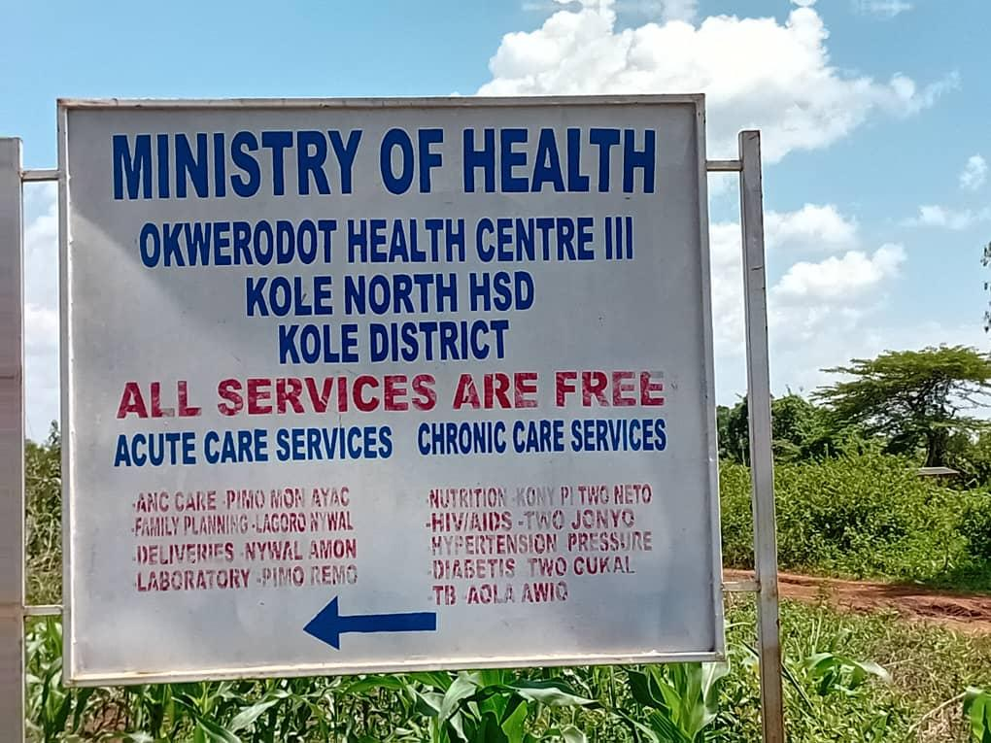
OUT PATIENT DEPARTMENT BLOCK | 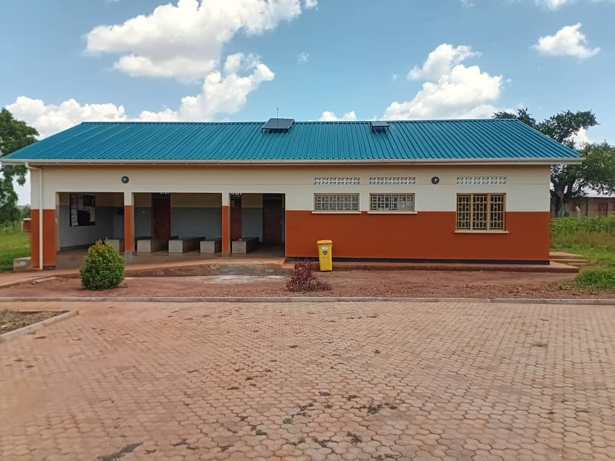
MATERNITY WARD/ BLOCK (FRONT VIEW) | 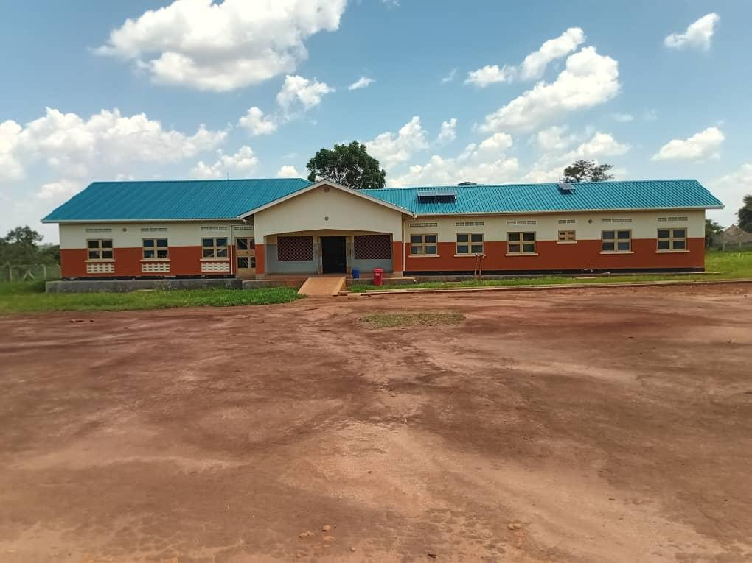
MATERNITY WARD/ BLOCK (BACK VIEW) | 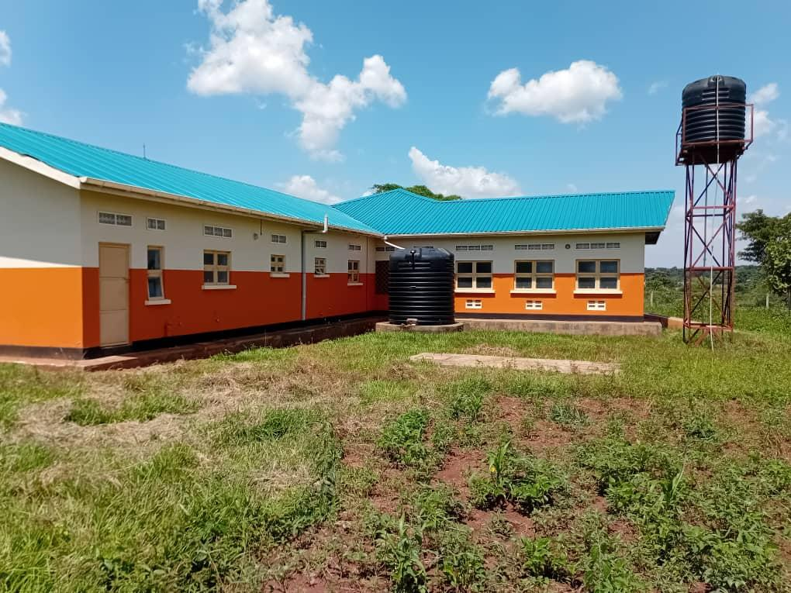
PLACENTA PIT | 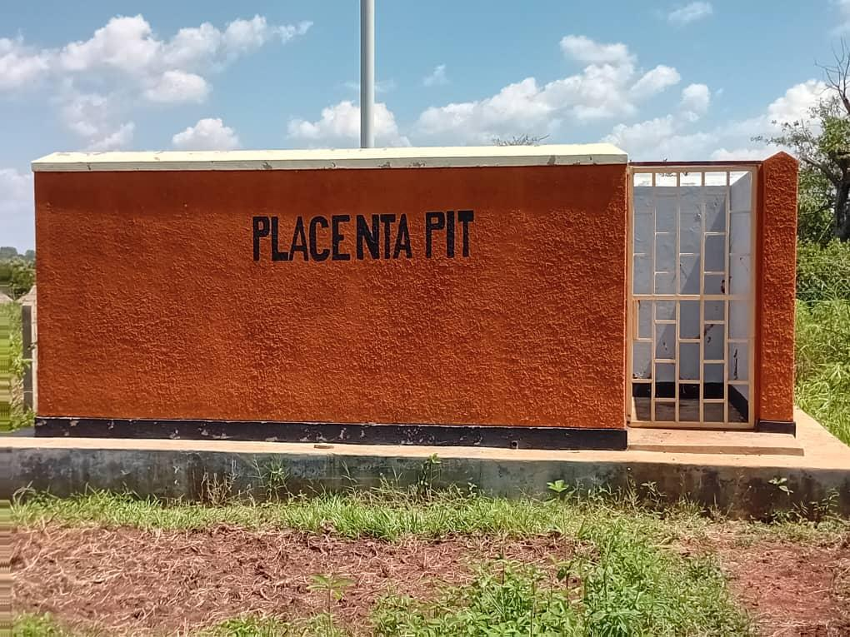
PATIENT PIT LATRINES (2 STANZAS FOR MEN AND 2 FOR WOMEN) | 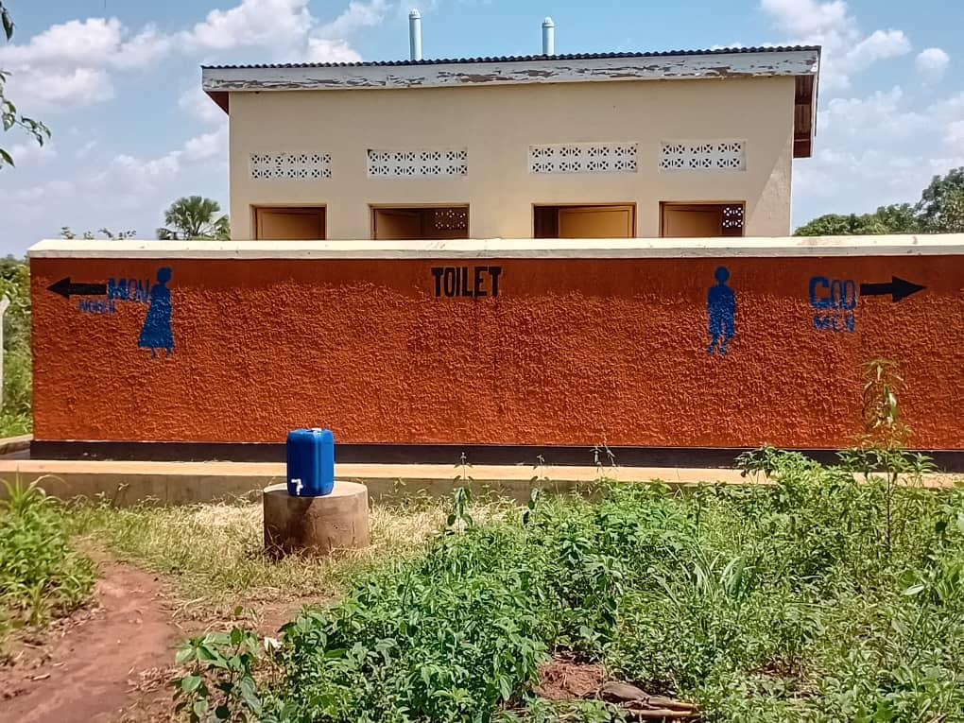
WATER TANKS (5000L AND 3000L SUPPLYING WATER TO THE WARD) | 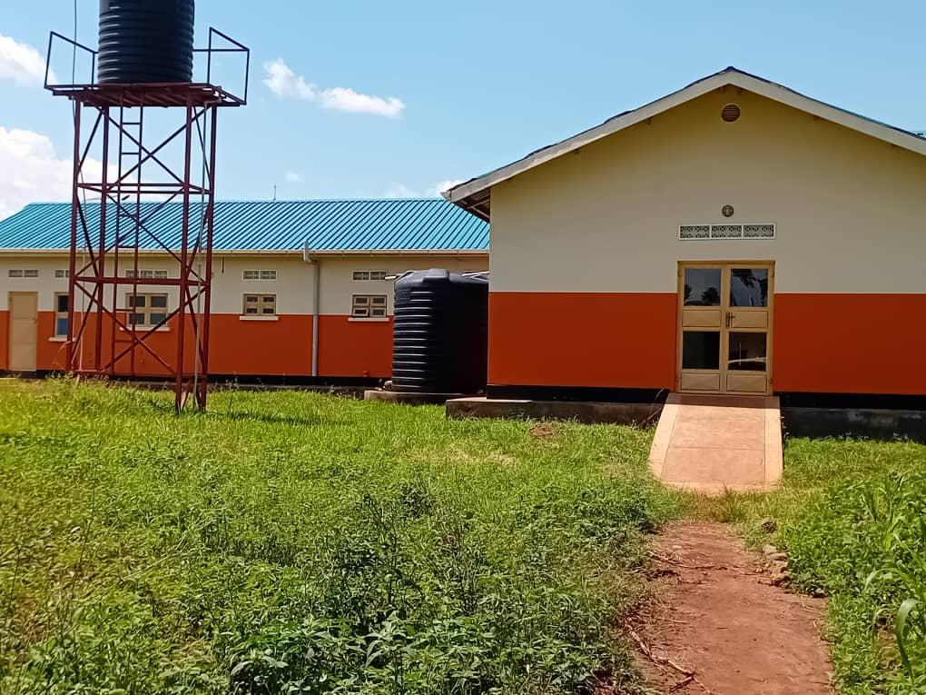
5000L WATER TANK COLLECTING RAIN WATER) | 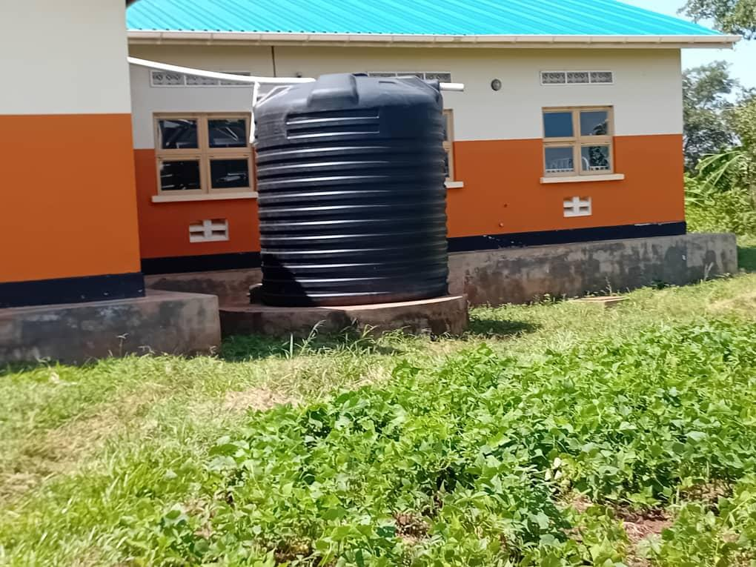
STAFF QUARTERS BLOCK (FRONT VIEW: 2 UNITS EACH BLOCK) | 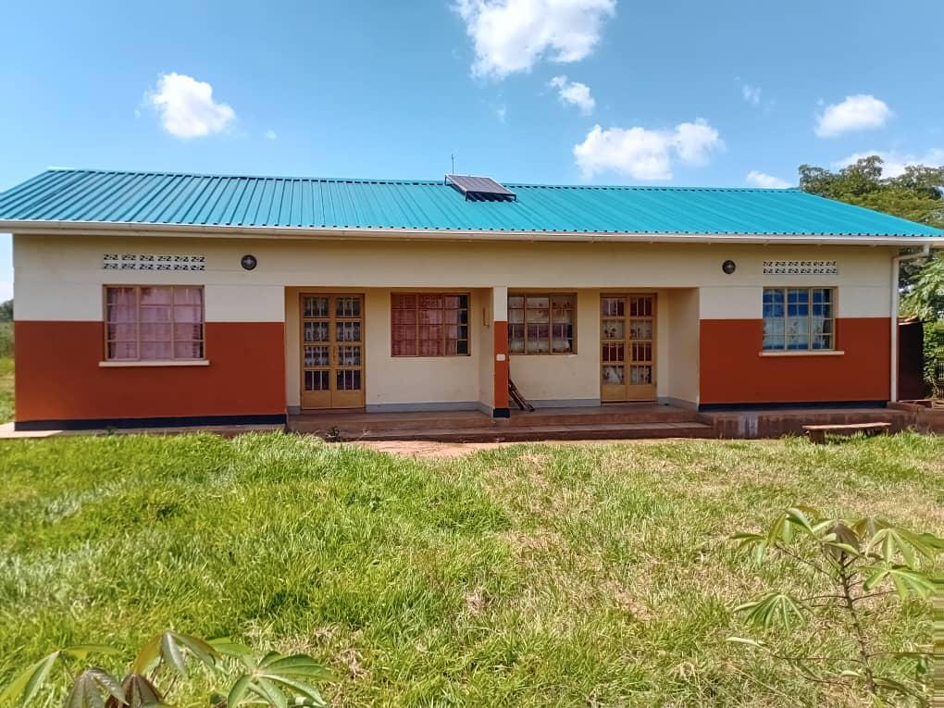
STAFF PIT LATRINES | 